**INTERNET TECHNOLGIES PRACTICAL**

**PRACTICAL 1**

**C:\Users>ipconfig**

Windows IP Configuration

Ethernet adapter Ethernet:

Media State . . . . . . . . . . . : Media disconnected

Connection-specific DNS Suffix . :

Wireless LAN adapter Local Area Connection* 1:

Media State . . . . . . . . . . . : Media disconnected

Connection-specific DNS Suffix . :

Wireless LAN adapter Local Area Connection* 2:

Media State . . . . . . . . . . . : Media disconnected

Connection-specific DNS Suffix . :

Wireless LAN adapter Wi-Fi:

Connection-specific DNS Suffix . :

Link-local IPv6 Address . . . . . : fe80::5828:36b4:f031:fa6c%4

**IPv4 Address. . . . . . . . . . . : 192.168.1.12**

**Subnet Mask . . . . . . . . . . . : 255.255.255.0**

Default Gateway . . . . . . . . . : fe80::76da:daff:fecc:bb3a%4

192.168.1.1

Ethernet adapter Bluetooth Network Connection:

Media State . . . . . . . . . . . : Media disconnected

Connection-specific DNS Suffix . :

**IPv4 Address . . . . . . . . . . . : 192 . 168 . 1 . 12**

**Subnet Mask . . . . . . . . . . . : 255 . 255 . 255 . 0**

**--------------------------------------------**

**Subnet number 192 . 168 . 1 . 0**

**--------------------------------------------**

**First Ip Address 192 . 168 . 1 . 1**

**Last Ip Address 192 . 168 . 1 . 254**

**Broadcast Ip Address 192 . 168 . 1 . 255**

No Of Systems Possible Are : 254

**PRACTICAL 2**

**PING MY MOBILE NUMBER**

**IP ADDRESS -**192.168.1.5

**C:\Users>Ping 192.168.1.5**

Pinging 192.168.1.5 with 32 bytes of data:

Reply from 192.168.1.5: bytes=32 time=12ms TTL=64

Reply from 192.168.1.5: bytes=32 time=127ms TTL=64

Reply from 192.168.1.5: bytes=32 time=127ms TTL=64

Reply from 192.168.1.5: bytes=32 time=229ms TTL=64

Ping statistics for 192.168.1.5:

Packets: Sent = 4, Received = 4, Lost = 0 (0% loss),

Approximate round trip times in milli-seconds:

Minimum = 12ms, Maximum = 229ms, Average = 123ms

TRACE ROUTE 192.168.1.5

C:\Users\ap123>tracert 192.168.1.5

Tracing route to 192.168.1.5 over a maximum of 30 hops

1 4 ms 8 ms 4 ms 192.168.1.5

Trace complete.

**PING REMAINING ADDRESSES**

**C:\Users>Ping 192.168.1.3**

Pinging 192.168.1.3 with 32 bytes of data:

Reply from 192.168.1.3: bytes=32 time=19ms TTL=64

Reply from 192.168.1.3: bytes=32 time=7ms TTL=64

Reply from 192.168.1.3: bytes=32 time=5ms TTL=64

Reply from 192.168.1.3: bytes=32 time=15ms TTL=64

Ping statistics for 192.168.1.3:

Packets: Sent = 4, Received = 4, Lost = 0 (0% loss),

Approximate round trip times in milli-seconds:

Minimum = 5ms, Maximum = 19ms, Average = 11ms

**C:\Users>Ping 192.168.1.6**

Pinging 192.168.1.6 with 32 bytes of data:

Reply from 192.168.1.12: Destination host unreachable.

Reply from 192.168.1.12: Destination host unreachable.

Reply from 192.168.1.12: Destination host unreachable.

Reply from 192.168.1.12: Destination host unreachable.

Ping statistics for 192.168.1.6:

Packets: Sent = 4, Received = 4, Lost = 0 (0% loss),

**C:\Users>Ping 192.168.1.1**

Pinging 192.168.1.1 with 32 bytes of data:

Reply from 192.168.1.1: bytes=32 time=3ms TTL=30

Reply from 192.168.1.1: bytes=32 time=3ms TTL=30

Reply from 192.168.1.1: bytes=32 time=3ms TTL=30

Reply from 192.168.1.1: bytes=32 time=3ms TTL=30

Ping statistics for 192.168.1.1:

Packets: Sent = 4, Received = 4, Lost = 0 (0% loss),

Approximate round trip times in milli-seconds:

Minimum = 3ms, Maximum = 3ms, Average = 3ms

C:\Users\ap123>tracert 192.168.1.1

Tracing route to 192.168.1.1 over a maximum of 30 hops

1 3 ms 4 ms 4 ms 192.168.1.1

Trace complete.

**C:\Users>Ping 192.168.1.2**

Pinging 192.168.1.2 with 32 bytes of data:

Reply from 192.168.1.2: bytes=32 time=118ms TTL=64

Reply from 192.168.1.2: bytes=32 time=109ms TTL=64

Reply from 192.168.1.2: bytes=32 time=105ms TTL=64

Reply from 192.168.1.2: bytes=32 time=89ms TTL=64

Ping statistics for 192.168.1.2:

Packets: Sent = 4, Received = 4, Lost = 0 (0% loss),

Approximate round trip times in milli-seconds:

Minimum = 89ms, Maximum = 118ms, Average = 105ms

C:\Users\ap123>tracert 192.168.1.2

Tracing route to 192.168.1.2 over a maximum of 30 hops

1 156 ms 11 ms 23 ms 192.168.1.2

Trace complete.

**C:\Users>Ping 192.168.1.10**

Pinging 192.168.1.10 with 32 bytes of data:

Reply from 192.168.1.10: bytes=32 time=1065ms TTL=64

Reply from 192.168.1.10: bytes=32 time=28ms TTL=64

Reply from 192.168.1.10: bytes=32 time=116ms TTL=64

Reply from 192.168.1.10: bytes=32 time=111ms TTL=64

Ping statistics for 192.168.1.10:

Packets: Sent = 4, Received = 4, Lost = 0 (0% loss),

Approximate round trip times in milli-seconds:

Minimum = 28ms, Maximum = 1065ms, Average = 330ms

C:\Users\ap123>tracert 192.168.1.10

Tracing route to 192.168.1.10 over a maximum of 30 hops

1 DESKTOP-VFJ6PDB [192.168.1.12] reports: Destination host unreachable.

Trace complete.

**C:\Users>Ping 192.168.1.12**

Pinging 192.168.1.12 with 32 bytes of data:

Reply from 192.168.1.12: bytes=32 time<1ms TTL=128

Reply from 192.168.1.12: bytes=32 time<1ms TTL=128

Reply from 192.168.1.12: bytes=32 time<1ms TTL=128

Reply from 192.168.1.12: bytes=32 time<1ms TTL=128

Ping statistics for 192.168.1.12:

Packets: Sent = 4, Received = 4, Lost = 0 (0% loss),

Approximate round trip times in milli-seconds:

Minimum = 0ms, Maximum = 0ms, Average = 0ms

**NETSTAT**

*Command – netstat*

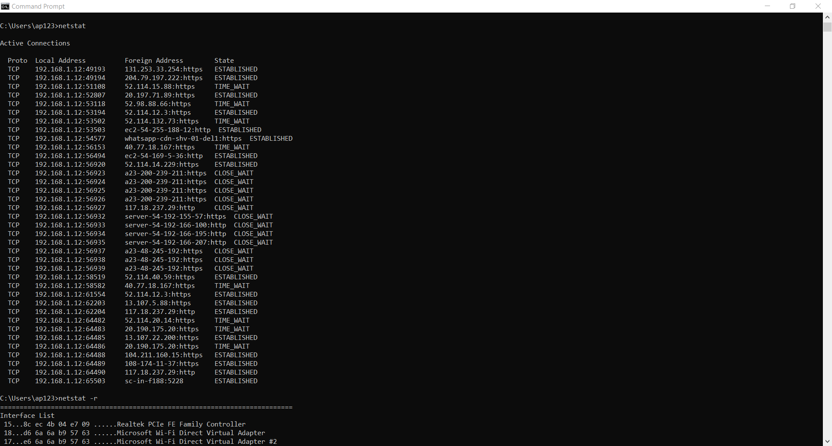

*Command – netstat -r*

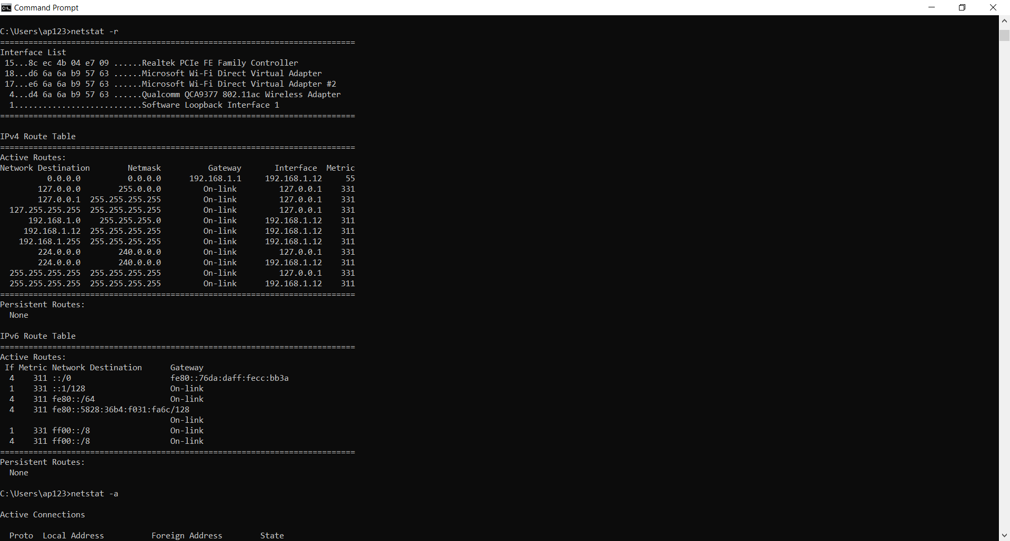

*Command – netstat-a*

